

Programming

Project Matrix Calculator

Instructor: Sir Shehzad Ahmad

Submitted by

Umer Ghafoor_22I-2328

Umair Idrees_22I-2319

Table of Contents

Group Members 3

Project Description 3

Results 3

Break down 7

Step 1 (Planning) 7

Step 2 (Coding) 7

By Umair Idrees 7

By Umer Ghafoor 7

Step 3 (Beta testing) 7

By Umair Idrees 7

By Umer Ghafoor 7

Step 4 (Enhancing the program) 7

By Umer Ghafoor 7

Step 5 (Documentation) 7

Improving efficiency 8

Removing (using namespace std;) 8

**Matrix Calculator**

# Group Members

Umer Ghafoor ------------------------------------------------------------------------------------- 22I-2328

Umair Idrees-----------------------------------------------------------------------------------------22I-2319

# Project Description

In this project, we have to implement a matrix system based on its order. The matrix must be square (i.e. rows and columns must be the same). The program initially asks the user to enter the order (N) of matrix A and its elements. The program presents the user with a choice (1- 7) to perform specific tasks given below.

1. To display a matrix
2. To check whether the entered matrix is symmetric or not
3. To check whether the entered matrix is an identity matrix or not.
4. To determine the determinant of the entered matrix.
5. To determine the adjoint of an entered matrix.
6. To determine the inverse of an entered matrix.
7. To determine the solution of the entered matrix (i.e., solving multiple linear equations simultaneously)
8. To Arithmetic

# Results

Input

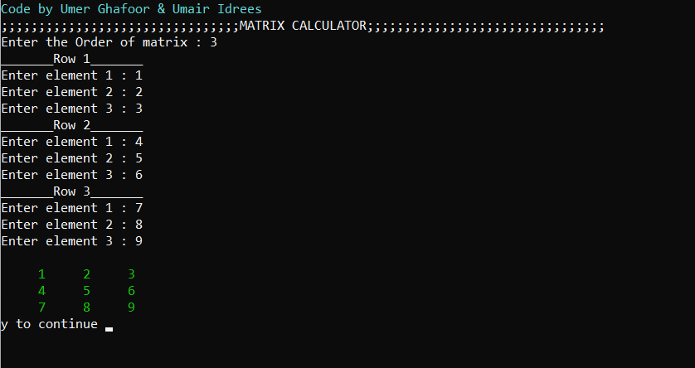

Task 1

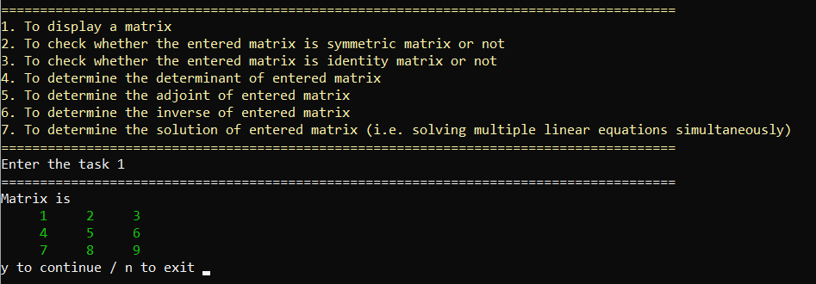

Task 2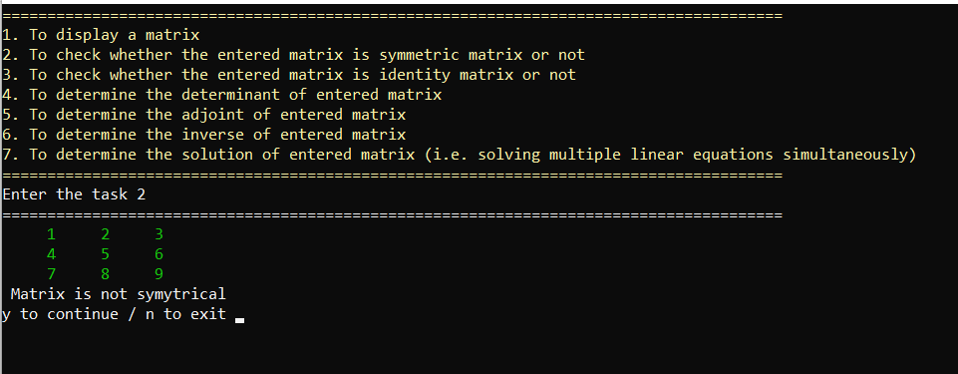

Task 3

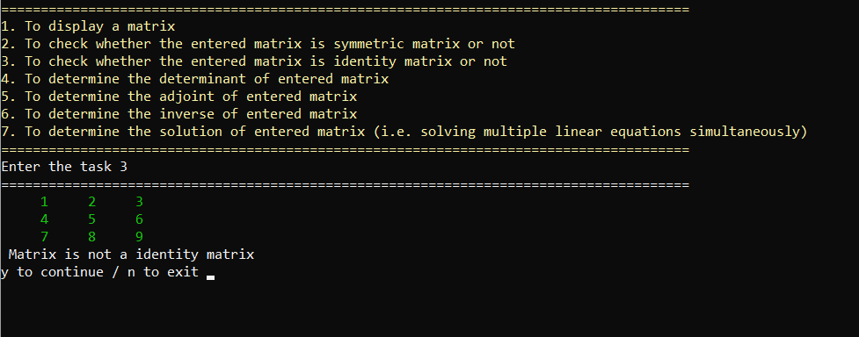

Task 4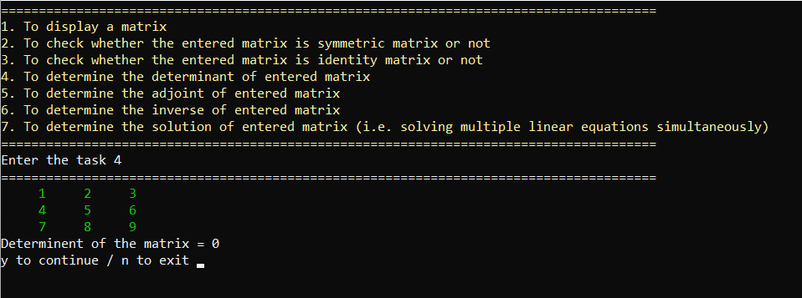

Task 5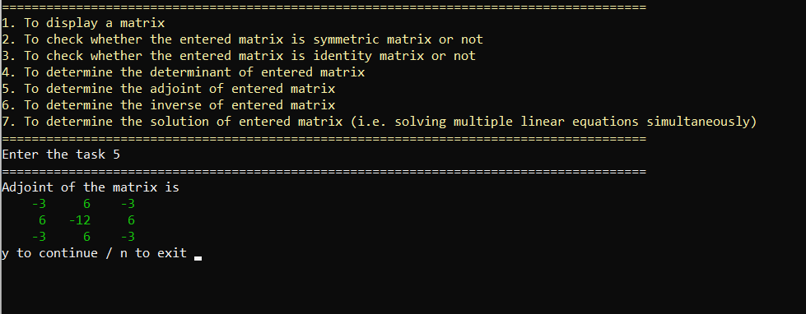

Task 6 (Note: Matrix is changed)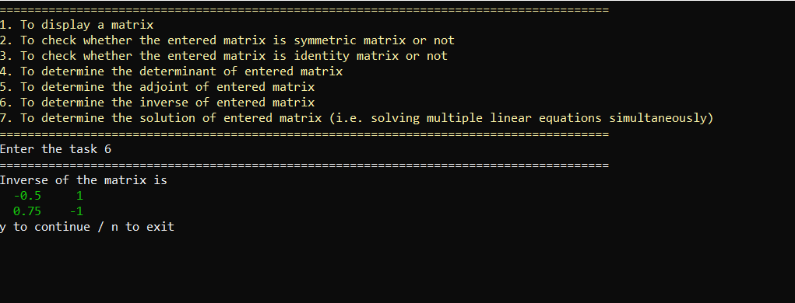

Task 7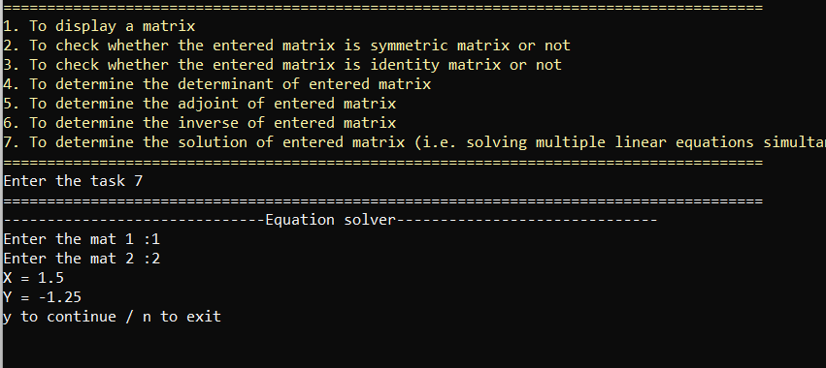

# Break down

## Step 1 (Planning)

Project Planning (Flow chart & ruff work) by Umer Ghafoor.

## Step 2 (Coding)

### By Umair Idrees

* Taking Inputs.
* Code to display the matrix.
* Check the symmetry.
* Check for Identity Matrix.

### By Umer Ghafoor

* Determine the determinant of an entered matrix.
* Determined the inverse of an entered matrix.
* Solving multiple linear equations simultaneously.
* Determined the adjoint of an entered matrix.

## Step 3 (Beta testing)

### By Umair Idrees

Run the code and determine whether the code is working properly or not calculator is used in this regard & reported the issues to Umer Ghafoor

### By Umer Ghafoor

Fixed the issues reported by Umair Idrees.

## Step 4 (Enhancing the program)

### By Umer Ghafoor

After Fixing the issues I Transformed the Raw Code & make it understandable for everyone. So that anyone can operate our program. Instructions are Given. Colors and other formatting techniques are used in this regard.

i.e., #include<iomanip> //set precision and set width

#include<windows.h> //To clear the console & to change color

## Step 5 (Documentation)

Documentation is done by Umair Idrees.

# Improving efficiency

## Removing (using namespace std;)

Before After

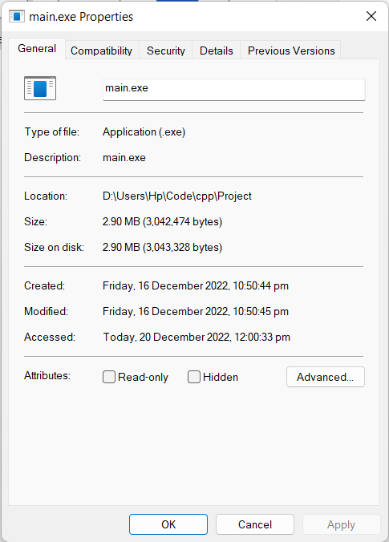

The size of the code was reduced by 97.61%.